Novel Coronavirus(2019-nCoV)
Situation Report - 10

Data as reported by 30 January 2020*

HIGHLIGHTS

- The Emergency Committee on the novel coronavirus (2019-nCoV) under the International Health Regulations (IHR 2005) is meeting today to discuss whether the outbreak constitutes a public health emergency of international concern.

- First confirmed cases of 2019-nCoV acute respiratory disease in Finland, India and Philippines; all had travel history to Wuhan City.

- On 29 January, WHO held its third press briefing to provide update on the situation. The audio can be found here.

- WHO recommends that the interim name of the disease causing the current outbreak should be “2019-nCoV acute respiratory disease” (where ‘n’ is for novel and ‘CoV’ is for coronavirus). This name complies with the WHO Best Practices for Naming of New Human Infectious Diseases, which were developed through a consultative process among partner agencies. Endorsement for the interim name is being sought from WHO’s partner agencies, World Organization for Animal Health (OIE) and Food and Agriculture Organization (FAO). The final name of the disease will be provided by the International Classification of Diseases (ICD). WHO is also proposing ‘2019-nCoV’ as an interim name of the virus. The final decision on the official name of the virus will be made by the International Committee on Taxonomy of Viruses.

SITUATION IN NUMBERS

Globally
7818 confirmed

China
7736 confirmed
12167 suspected
1370 severe
170 deaths

Outside of China
82 confirmed
18 countries

WHO RISK ASSESSMENT
China | Very High
Regional Level | High
Global Level | High

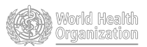
Figure 1. Countries, territories or areas with reported confirmed cases of 2019-nCoV, 30 January 2020
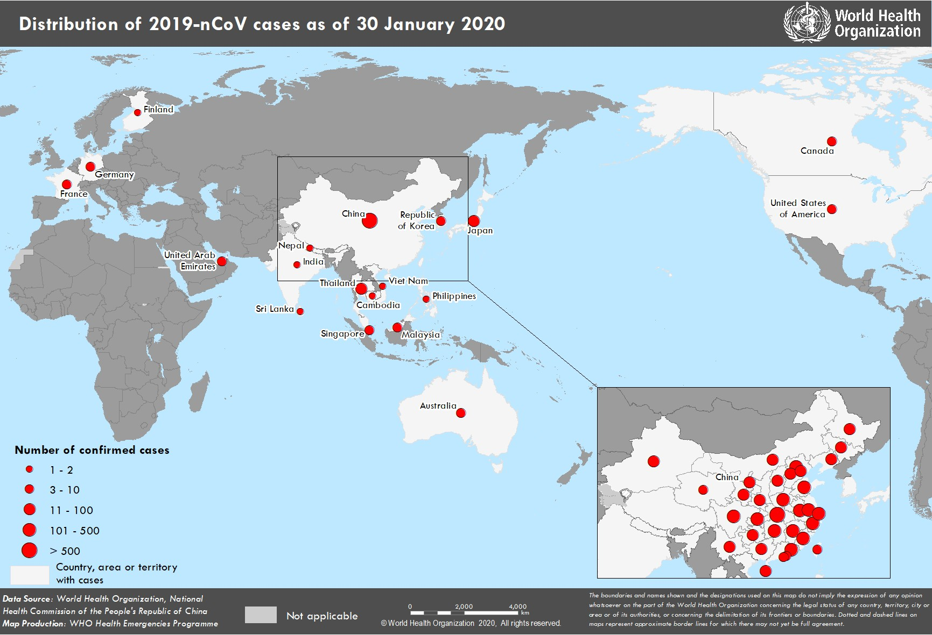
*The situation report includes information reported to WHO Geneva by 10 AM

TECHNICAL FOCUS: Laboratory detection:

WHO published interim laboratory guidance for detection of the novel coronavirus on 9 January and has updated that advice twice. This guidance includes advice on biosafety, patient sampling, and pathogen detection and characterization. Like the epidemiologic situation, the diagnostic landscape is changing quickly. The first 2019-nCoV cases were detected using metagenomic sequencing. Within days of obtaining the sequence data polymerase chain reaction (PCR) assays were developed for clinical diagnostic use. Multiple academic and public-sector groups, including China Center for Disease Control and Prevention (CDC), have designed assays targeting areas of the genome detecting sequences specific for the novel virus (2019-nCoV) and have made them publicly available.

One of WHO’s main aims is to strengthen global diagnostic capacity for 2019-nCoV detection to improve surveillance, early detection and track the spread of disease. To date, human- to- human transmission outside of China has been limited, and public health efforts are targeted at limiting further transmission in countries with imported cases which depends critically on the ability to detect the pathogen.

WHO has taken a three-pronged approach to enhance diagnostic capacity for 2019-nCoV:
- Forming a network of specialized referral laboratories with demonstrated expertise in the molecular detection of coronaviruses. These international labs can support national labs to confirm 2019-nCoV cases and troubleshoot their molecular assays;
- Strengthening national capacity for detection of 2019-nCoV so that diagnostic testing can be performed rapidly without the need for overseas shipping. One way this has been achieved is through working with existing global networks for detection of respiratory pathogens such as, notably, the National Influenza Centers that support the Global Influenza Surveillance and Response System;
- Ensuring test availability. This has involved a) screening of 2019-nCoV PCR protocols from academic laboratories for validation data (e.g. limits of detection, specificity), b) looking for sequence alignment of established commercial coronavirus assays (e.g. SARS) to see if any were likely to be able to detect 2019- nCoV with high sensitivity, and c) working with commercial and non-commercial agencies with capacity to manufacture and distribute newly-developed 2019-nCoV PCR assays. WHO will begin supporting its regional and country offices to make these tests available the first week of February 2020.
SURVEILLANCE

Table 1. Countries, territories or areas with reported confirmed cases of 2019-nCoV, 30 January 2020

WHO Regional Office | Country/Territory/Area | Confirmed Cases
Western Pacific | China* | 7736
Western Pacific | Japan | 11
Western Pacific | Republic of Korea | 4
Western Pacific | Viet Nam | 2
Western Pacific | Singapore | 10
Western Pacific | Australia | 7
Western Pacific | Malaysia | 7
Western Pacific | Cambodia | 1
Western Pacific | Philippines | 1
South-East Asia | Thailand | 14
South-East Asia | Nepal | 1
South-East Asia | Sri Lanka | 1
South-East Asia | India | 1
Region of the Americas | United States of America | 5
Region of the Americas | Canada | 3
European Region | France | 5
European Region | Finland | 1
European Region | Germany | 4
Eastern Mediterranean | United Arab Emirates | 4
Total Confirmed cases | Total | 7818
*Confirmed cases in China include cases confirmed in Hong Kong SAR (10 confirmed cases), Macau SAR (7 confirmed cases) and Taipei (8 confirmed cases).

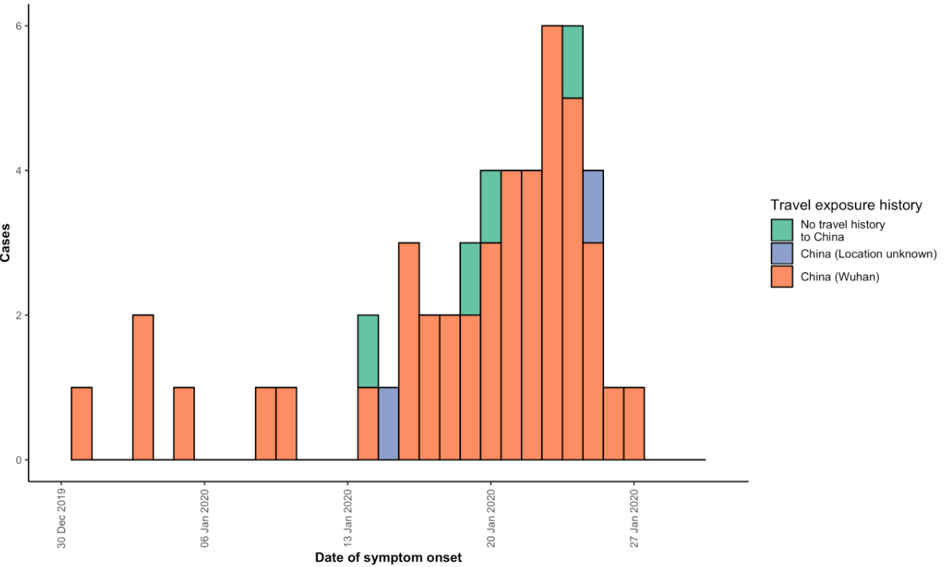

Note for figure 2: Of the 82 cases reported outside China, seven were detected while asymptomatic. For the remaining 75 cases, information on date of onset is available only for the 49 cases presented in the epidemiologic curve.

STRATEGIC OBJECTIVES

WHO’s strategic objectives for this response are to:

- Limit human-to-human transmission including reducing secondary infections among close contacts and health care workers, preventing transmission amplification events, and preventing further international spread from China*;
- Identify, isolate and care for patients early, including providing optimized care for infected patients;
- Identify and reduce transmission from the animal source;
- Address crucial unknowns regarding clinical severity, extent of transmission and infection, treatment options, and accelerate the development of diagnostics, therapeutics and vaccines;
- Communicate critical risk and event information to all communities and counter misinformation;
- Minimize social and economic impact through multisectoral partnerships.

*This can be achieved through a combination of public health measures, such as rapid identification, diagnosis and management of the cases, identification and follow up of the contacts, infection prevention and control in healthcare settings, implementation of health measures for travellers, awareness- raising in the population and risk communication.

  - WHO has developed a protocol for the investigation of early cases (the “First Few X (FFX) Cases and contact investigation protocol for 2019-novel coronavirus (2019-nCoV) infection”). The protocol is designed to gain an early understanding of the key clinical, epidemiological and virological characteristics of the first cases of 2019- nCoV infection detected in any individual country, to inform the development and updating of public health guidance to manage cases and reduce potential spread and impact of infection.
  - WHO has been in regular and direct contact with Member States where cases have been reported. WHO is also informing other countries about the situation and providing support as requested.
  - WHO has developed interim guidance for laboratory diagnosis, advice on the use of masks during home care and in health care settings in the context of the novel coronavirus (2019-nCoV) outbreak, clinical management, infection prevention and control in health care settings, home care for patients with suspected novel coronavirus, risk communication and community engagement.
  - Prepared disease commodity package that includes an essential list of biomedical equipment, medicines and supplies necessary to care for patients with 2019-nCoV.
  - WHO has provided recommendations to reduce risk of transmission from animals to humans.
  - WHO has published an updated advice for international traffic in relation to the outbreak of the novel coronavirus 2019-nCoV.
  - Activation of R&D blueprint to accelerate diagnostics, vaccines, and therapeutics.
  - WHO has developed an online course to provide general introduction to emerging respiratory viruses, including novel coronaviruses.
  - WHO is providing guidance on early investigations, which are critical to carry out early in an outbreak of a new virus. The data collected from the protocols can be used to refine recommendations for surveillance and case definitions, to characterize the key epidemiological transmission features of 2019-nCoV, help understand spread, severity, spectrum of disease, impact on the community and to inform operational models for implementation of countermeasures such as case isolation, contact tracing and isolation. The first protocol that is available is a: Household transmission investigation protocol for 2019-novel coronavirus (2019-nCoV) infection.
  - WHO is working with its networks of researchers and other experts to coordinate global work on surveillance, epidemiology, modelling, diagnostics, clinical care and treatment, and other ways to identify, manage the disease and limit onward transmission. WHO has issued interim guidance for countries, updated to take into account the current situation.
- WHO is working with global expert networks and partnerships for laboratory, infection prevention and control, clinical management and mathematical modelling.

RECOMMENDATIONS AND ADVICE

During previous outbreaks due to other coronavirus (Middle-East Respiratory Syndrome (MERS) and Severe Acute Respiratory Syndrome (SARS), human-to-human transmission occurred through droplets, contact and fomites, suggesting that the transmission mode of the 2019-nCoV can be similar. The basic principles to reduce the general risk of transmission of acute respiratory infections include the following:

- Avoiding close contact with people suffering from acute respiratory infections.
- Frequent hand-washing, especially after direct contact with ill people or their environment.
- Avoiding unprotected contact with farm or wild animals.
- People with symptoms of acute respiratory infection should practice cough etiquette (maintain distance, cover coughs and sneezes with disposable tissues or clothing, and wash hands).
- Within healthcare facilities, enhance standard infection prevention and control practices in hospitals, especially in emergency departments.

WHO does not recommend any specific health measures for travellers. In case of symptoms suggestive of respiratory illness either during or after travel, travellers are encouraged to seek medical attention and share their travel history with their healthcare provider.
Resources:
- Technical interim guidance for novel coronavirus, WHO: https://www.who.int/emergencies/diseases/novel-coronavirus-2019
- WHO travel advice for international travel and trade in relation to the outbreak of the novel coronavirus 2019-nCoV
https://www.who.int/ith/2020-24-01-outbreak-of-Pneumonia-caused-by-new-coronavirus/en/
- Readiness is the key to detect, combat spread of the new coronavirus:
https://www.who.int/southeastasia/news/detail/27-01-2020-readiness-is-the-key-to-detect-combat- spread-of-the-new-coronavirus
- WHO’s Eastern Mediterranean Region scales up preparedness for novel coronavirus http://www.emro.who.int/media/news/whos-eastern-mediterranean-region-scales-up-preparedness-for- novel-coronavirus.html
- Press statements by KCDC (in Korean): https://www.cdc.go.kr/board/board.es?mid=a20501000000&bid=0015
- Wuhan Municipal Health Commission's briefing on the pneumonia epidemic situation, (in Chinese): http://wjw.wuhan.gov.cn/front/web/list2nd/no/710
- Disease outbreak news, Novel Coronavirus: https://www.who.int/csr/don/en/
- Thailand Ministry of Public Health situation update on novel coronavirus (in Thai): https://ddc.moph.go.th/viralpneumonia/index.html
- Press statement by Ministry of Health, Labour and Welfare, Japan (in Japanese): https://www.mhlw.go.jp/stf/houdou/houdou_list_202001.html
- Notice sent out from Health and Food Safety Planning Division, Quarantine Station Operation Management Office (in Japanese): https://www.mhlw.go.jp/content/10900000/000582967.pdf
- Situation report by WHO on Novel Coronavirus (2019-nCoV) https://www.who.int/emergencies/diseases/novel-coronavirus-2019
- CDC press release. First Travel-related Case of 2019 Novel Coronavirus Detected in United States https://www.cdc.gov/media/releases/2020/p0121-novel-coronavirus-travel-case.html
- Hong Kong SAR Department of Health, Press Release https://www.info.gov.hk/gia/general/202001/23/P2020012300970.htm
- Epidemic Prevention Measures, Macau SAR Health Bureau https://www.ssm.gov.mo/apps1/PreventWuhanInfection/ch.aspx#clg17048
- Press release on 23 January 2020, Ministry of Health Singapore.
https://www.moh.gov.sg/news-highlights/details/confirmed-imported-case-of-novel-coronavirus- infection-in-singapore-multi-ministry-taskforce-ramps-up-precautionary-measures
- CDC press release. Second Travel-related Case of 2019 Novel Coronavirus Detected in United States https://www.cdc.gov/media/releases/2020/p0124-second-travel-coronavirus.html
- New South Wales Government: Health: Coronavirus cases confirmed in NSW https://www.health.nsw.gov.au/news/Pages/20200125_03.aspx

